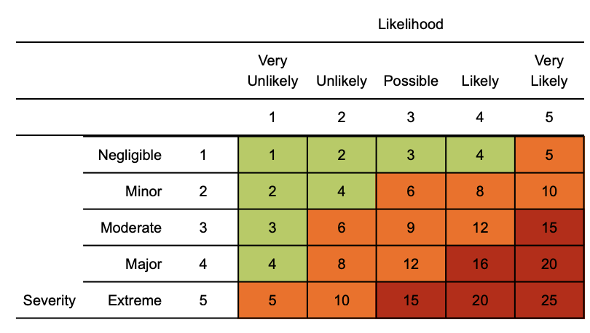

COVID-19 Risk Assessment & Control Plan
November 2020

Overall Risk Rating: Green/Amber (COVID-19 Secure)

Risk Assessment Record
Site: | Traynor Way and Mill Hill |  | Work Activities:
Date: | 06th November 2020 |  | Assessed by: | Sarah Johnson |  |  | R.A. Number: |  |  | RA23
Approved by: |  | Richard Egginton |  | Version 2
 |  |  |  | At Risk
 |  |  |  | Workers |  | Visitors |  |  | Occupational Health and Safety
 |  |  |  | Contractors |  | Public

Ref | Hazard/Issue | Risk Before Controls |  |  | Control Measures to Eliminate/Reduce the Risk | Risk After Controls |  |  | Further Action Required
 |  | L | C | R |  | L | C | R
0  1  2  3  4  6  7  8  9  10  12 | General Guidance  Government Advice  Face Coverings  Staffing  Symptoms of COVID-19  Return to Work  Transport  Communications  Training  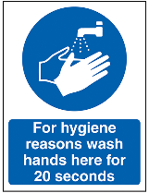  Hand Hygiene  Outside of Work  Arriving to work  Entry/Exit to Building  Personal Equipment  Doors and Handles  Walkways and Access Routes  Working Conditions  Office Layout  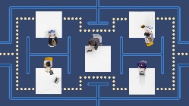  Shared Office Equipment  Factory  Shared Welfare Facilities  Kitchen  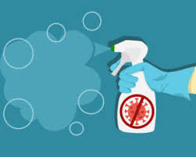  Bathrooms  Cleaning  Office  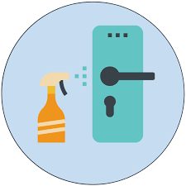  Emergency Situations  Fire  First Aid  Developing Symptoms of Coronavirus  Staff  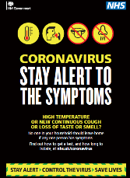  Confirmed Case of Coronavirus  Staff  Mental Health  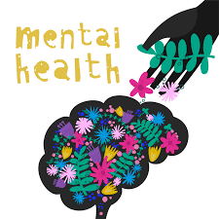  Wellbeing | 3  3  3  3  3  3  3  3  3  3  3  2  3  2  3  3  2  2  3  3  2  2 | 4  4  4  4  4  4  4  4  4  4  4  4  4  4  4  4  4  4  4  4  5  3 | 12  12  12  12  12  12  12  12  12  12  12  8  12  8  12  12  8  12  12  10  6 | - Official HM Government guidance shall be followed at all times (see further action column)  - Wearing face covers are now mandatory around the UK for retail and hospitality but not in all workplaces. They are not an effective way to manage the risks from coronavirus and you should not rely on them. Our staff at Sotech are required to wear face coverings when away from their desks and fully mandatory in the manufacturing area.  - Staff must not come to work if they have symptoms of COVID-19 or live in a household where someone has a confirmed case of COVID-19.  - A return to work assessment is to be carried out taking into account GRPR requirements (sharing and storing information). This assessment will cover:  - Identification of pre-existing conditions (to be checked if in the ‘at risk’ category via the NHS website. If staff are identified be in an high risk category or shielding they cannot return to work  - Transport to work considerations. The use of public transport is discouraged. If unavoidable a face mask must be worn and good hygiene practices. See Government guidance on traveling to and from work.  - Regular briefings to be provided to staff on latest Governmental and NHS advice regarding safe working (as and when advice is revised and updated).  - The controls within this risk assessment will be reinforced to all staff daily.  - Staff training is needed on COVID-19 and how to sensibly manage the risks. All staff to be trained in the control measures in place (hygiene controls, social distancing, que management).  - Records of all training must be kept.  - All staff must wash their hand immediately upon arrival at work or when they re-enter the workplace having been outside, regularly during the day and before leaving.  - Hands should be washed using soap and water following the guidance provided by UK Government  - Alcohol based (min 60%) hand sanitisers to be positioned within the office to encourage use by staff at entrances/exists, shared equipment i.e printers.  - Staff are encouraged to follows best practice Governmental advice.  - Social distancing must be adhered to at all times following latest Government advice.  - Staggered arrival and departure times for staff  - Use of multiple entry/exit points.  - Staff must use alcohol based hand sanitiser before entering the building.  - Equipment and items such as mobile phone, laptop, car keys, handbag, wallet which are frequently touches must be cleaned with antibacterial wipes.  - Door handles to be frequently cleaned; doors propped open where possible.  - Staff are reminded to social distance from others and not to congregate in walkways.  - Offices to be well-ventilated (open door and windows) where possible.  Office reconfigured to allow social distancing among workers seating arrangements. Where this has been identified as not possible;  - Staff are required to sit back-to-back or side-to-side (rather than face-to-dace) where possible.  - Frequent hand washing and surface cleaning must take place inc. work stations.  - Workstations are assigned to an individual and not shared.  - Shared equipment must be cleaned before and after use (phones, printers).  - Factory is spacious and well ventilated. Factory doors to remain open to aid ventilation where possible.  - All employees informed to stay 2 metres apart from other employees and customers (or 1 metre with risk mitigation where 2 metres is not viable)  - Signs and floor tape remind people to keep social distance.  - Shared equipment (tools and machinery) to be cleaned before and after use.  Where staff cannot stay 2 metres apart (or 1 metre with risk mitigation where 2 metres is not viable) the following controls will be implemented:  - only work closely together up to 15 minutes at a time  - use screens and barriers to separate people where possible  - work side by side or back-to-back rather than face-to-face  - have fixed teams to minimise exposure  - Staff are encouraged to bring their own meals and drinks from home and not leave site to visit local shops for lunch.  - Follow good hygiene controls when using shared kitchen facility. Clean surfaces prior to meal prep, use own cutlery and cups/mugs, wash hand after contact with common touch points (taps, handles, switches).  - Only enter is social distancing can be maintained.  - Staggered break for employees times reduce numbers accessing welfare facilities at the same time.  - Ensure good hand hygiene, wash hands for 20 seconds with warm water and soap.  - Use of disposal paper towels  - Hand sanitiser to provide for use on exit (after contact with door handles and locks)  The following official guidance for ‘keeping the workplace clean’ to be implemented:  - Frequent cleaning of work areas and equipment between uses, using usual cleaning products.  - Frequent cleaning of objects and surfaces that are touched regularly, such as door handles, machine controls and providing adequate disposal arrangements.  - Clearing workspaces and removing waste and belongings from the work area at the end of a shift.  - In an emergency, such as fire, staff are not required to social distance as it would be unsafe. Follow emergency plans in place.  - Try to assist at a safe distance from the casualty as much as you can and minimise the time you share a breathing zone. If they are capable, tell them to do things for you, but treating the casualty properly should be your first concern.  - If a member of staff develops, they must return home immediately. Ensuring not to touch any surfaces on their exit and to follow official self-isolation guidance. A thorough cleaning of the workplace including all frequently touched areas must take place.  - Other staff members are permitted to work but to be informed of a possible outbreak. Good hygiene controls to be increased in frequency whilst pending confirmation.  - In the result of a confirmed case all staff within the ‘fixed team’ and others which may have been in contact (shared facilities, visitors) should be informed and advised to self-isolate if they have had close contact (including those in their household). RIDDOR reporting of Covid-19 to be followed. Covid-19: cleaning in a non-healthcare setting guidance to be followed.  Regular contact with managers to discuss any areas of concern or opportunities for improvements.  Referrals to mental health charities and support groups. | 2  2  3  2  2  1  2  2  1  1  1  1  1  1  2  1  2  2  2  2  2  2 | 4  4  4  4  4  4  4  4  4  4  4  4  4  4  4  4  4  4  4  4  4  2 | 8  8  12  8  8  4  8  8  4  4  4  4  4  4  8  4  8  8  8  8  8  4 | ‘Working safely during coronavirus (COVID-19) in offices and contact centres’  Guidance for people who work in or run factories, plants and warehouses.  Monitor  Monitor  Refer to COVID-19 return to work assessment document  Monitor  Monitor  Covid Toolbox Talk signed electronically  Record date, name and topics covered.  Monitor  Regular communications  Monitor  Monitor  Monitor  Monitor  Monitor  Monitor  Monitor  Monitor  Monitor  Hand towel to be removed.  Monitor  Monitor  Monitor

